## Solution Environment:

1. Javascript
2. JQuery3.3.1
3. Bootstrap4.0
4. HTML5
5. CSS3

Please note, no framework is used as the solution has only one page.

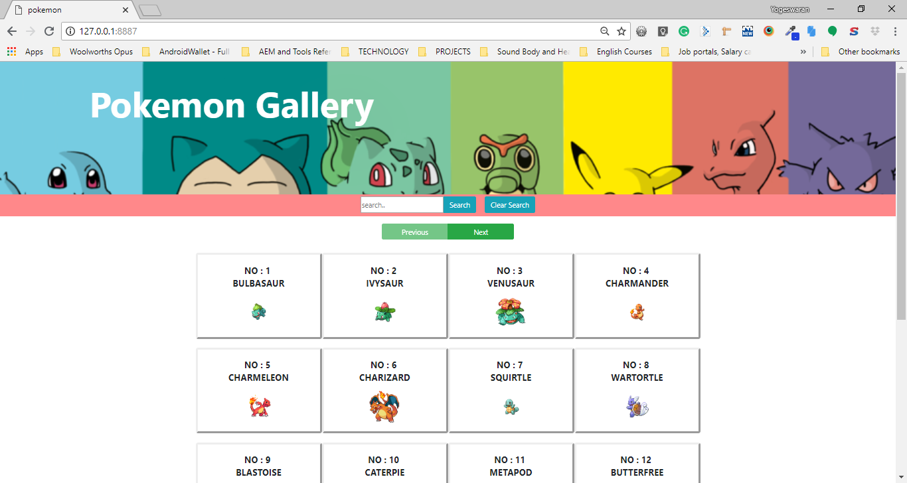

### Deployment Instructions:

1. Copy pokemon.zip to your local machine.
2. Unzip pokemon.zip (say at D:\ drive.), so that the folder strucuture looks like below:

(*Note: Make sure, unzipping didn’t create additional ‘pokeman’ folder like* ***D:\pokeman\pokeman***)

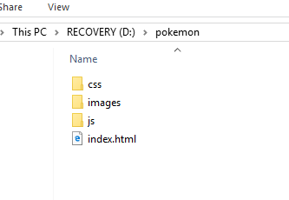

Note: The zip file has the following files and folder:

1. Index.html
2. Images folder (has pokemon icons)
3. Js folder (has jquery331.js, boostrap4.js, config.js and pokemon.js)
4. Css folder (has bootstrap4.min.css, pokemon.css)
5. For quick run, launch ‘webserver for Chrome’ (available at the below url):

<https://chrome.google.com/webstore/detail/web-server-for-chrome/ofhbbkphhbklhfoeikjpcbhemlocgigb?hl=en>

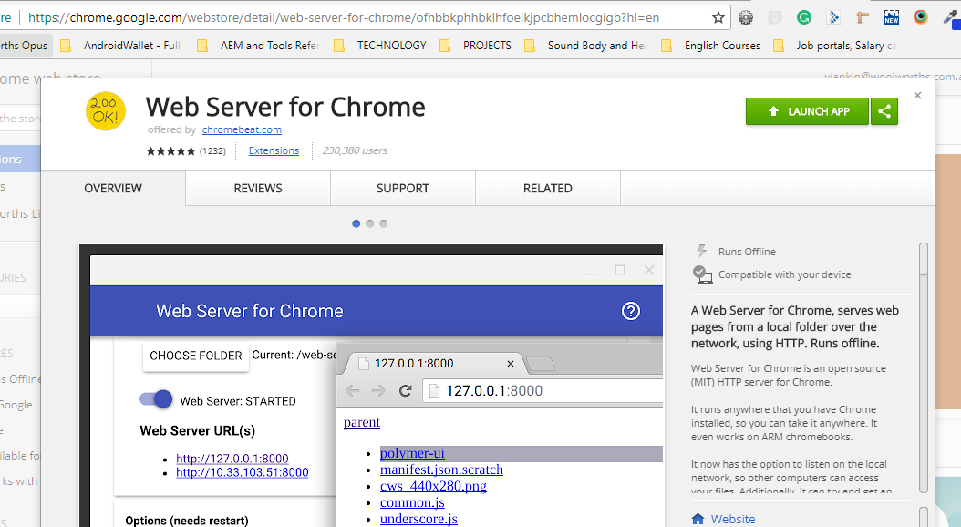

1. Once launched, click on ‘Choose folder’ button and select the ‘D:\pokemon’ folder:

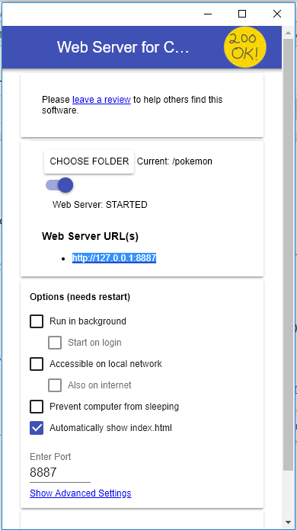

1. Click on the webserver URL ([http://127.0.0.1:*8887*](http://127.0.0.1:8887/)) to open in a browser and the below page should load:

